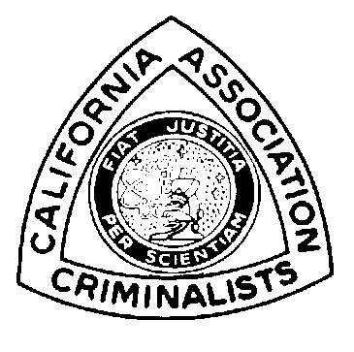

Seminar

Philip M. Kellett

Program

Donald T. Jones

Workshops

Caroline Kim

Registration

Caroline Kim
Hazel Whitworth

Vendors

John Johnson

Site

Norm Wallis

Advertisement
& Raffle

Stephanie Burton

San Bernardino
Sheriff’s Department
200 S. Lena Road
San Bernardino, CA
92415-0056

(909) 387-2200
(909) 387-2688 fax California Association of Criminalists
94th Semi-Annual Seminar
October 12 through 16, 1999

Pre-Registration After Sept 10, 1999 Student
FULL REGISTRATION Member Non Member Non Member Non
- Thursday, Friday, Saturday $ 140 $ 200 $ 170 $ 230 $ 50 $ 75
(includes lunches Thursday and Friday
and one banquet ticket)

DAILY REGISTRATION
- Thursday (lunch included) $ 60 $ 80 $ 75 $ 95 $ 15 $ 25
- Friday (lunch included) $ 50 $ 70 $ 65 $ 85 $ 10 $ 20
- Saturday $ 30 $ 50 $ 45 $ 60 $ 7 $ 10

WORKSHOPS (lunch included)
- Advanced Blood $ 120 $ 150 $ 140 $ 170
Pattern Interpretation (12 people)
(Tuesday and Wednesday)
- Clandestine Laboratory $ 120 $ 150 $ 140 $ 170
Documentation for Court (20 people)
(Tuesday and Wednesday)
- Power Point (20 people) $ 45 $ 75 $ 55 $ 85
(Tuesday)
- Microscopy of $ 75 $ 105 $ 85 $ 115
Botanical Traces (20 people)
(Wednesday)
- DNA Users Group $ 45 $ 75 $ 55 $ 85 $ 20
(Wednesday)

EXTRAS
- Banquet Tickets $ 35

Please send this form to Caroline Kim. One form per registrant.
Make check payable to: California Association of Criminalists.
Name:
Organization:
Address:
City: | State: Zip:
Phone: ( ) | e-mail:
CAC member? Yes No | Staying at the Hotel? Yes No
Student? Yes No (if not a CAC student member, please attach copy of student ID)
Credit Card Option: Visa M/C Credit Card # Exp:
Signature | Amount Enclosed:  $

